|  |  |  |  |
| --- | --- | --- | --- |
| Group Members | | | |
| Name | Userid | Name | Userid |
| Austin Lee | Aj5lee | Collins Chung | Chkchung |
| *By filling out the names above, the group members acknowledge that a) they have jointly authored this submission, b) this work represents their original work, c) that they have not been provided with nor examined another person's assignment, either electronically or in hard copy, and d) that this work has not been previously submitted for academic credit.* | | | |

**SE 380 Introduction to Feedback Control**

**Lab 2: Measurement Techniques – Prelab**

**Assigned Data**

Bench number: _______________________2

Assigned bandwidth (open‑loop)*: _______________1550 rad/s

Gain K: 4.00

* The value of the assigned bandwidth, between 600 rad/s and 2000 rad/s, depends on the station number you reserved in CourseBook and your lab session date; it can be found on the lab web page, under [[[Assigned Station Bandwidth](http://ece.uwaterloo.ca/~lab380/intronum.htm)](http://ece.uwaterloo.ca/~lab380/intronum.htm)](http://ece.uwaterloo.ca/~lab380/intronum.htm).

# Laboratory Objective

This lab is a structured introduction to the measurements that will be made throughout the SE 380 Lab. The following topics will be covered:

* connection and use of specialized breadboard modules;
* time constant measurement;
* bandwidth measurement in time‑domain and in frequency-domain.

**2. Prelab Calculations**

A review of concepts learned in MATH 213 may be necessary for completing this prelab. The required topics are the time constant and bandwidth of a first‑order open‑loop and closed‑loop system. The system under analysis is the RC circuit, G(s), depicted in Figure 1.

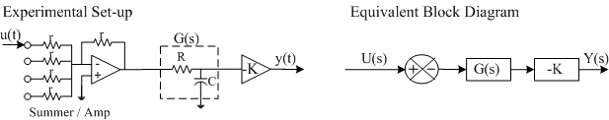

Figure 1. Open-loop system

The subsystem preceding G(s) in Figure 1 is the same as the summer/amplifier shown in Figure 1a of the Overview. The negative gain in the summer of the block diagram in Figure 1 exists because the operational amplifier is wired up as a unity‑gain inverter.

|  |  |  |
| --- | --- | --- |
| a) Using the assumptions for an ideal op‑amp, show that: | | |
|  | is equivalent to |  |

|  |
| --- |
|  |

b) Calculate the transfer function G(s) shown Figure 1.

|  |
| --- |
|  |

c) Calculate the transfer function Y(s)/U(s) as shown in Figure 1.

|  |
| --- |
|  |

d) Using the assigned gain K value, and the calculated transfer function Y(s)/U(s), select a suitable capacitance *C* value (within the decade capacitance range of 0.01 F to 1.1 F) and calculate the required resistance *R* (between 1 k and 100 k) such that the open‑loop system has the assigned bandwidth. For a low‑pass filter, such as the one under analysis, the bandwidth is defined as the frequency at which the system gain is equal to the low‑frequency gain less 3 dB. In time domain, this is translates into the frequency at which the low-frequency gain of the system decreases by a factor of .

|  |
| --- |
|  |

e) In the open-loop transfer function Y(s)/U(s) obtained in (c), substitute the values from (d) for K, R, and C. Draw/hand-sketch the asymptotic Bode plot for this transfer function, which should include:

- plots for both magnitude and phase;

- any steps and calculations you made to obtain specific values on the plot;

- labelled axes, units used, and any relevant values (e.g., low-frequency gain, corner frequency, etc.).

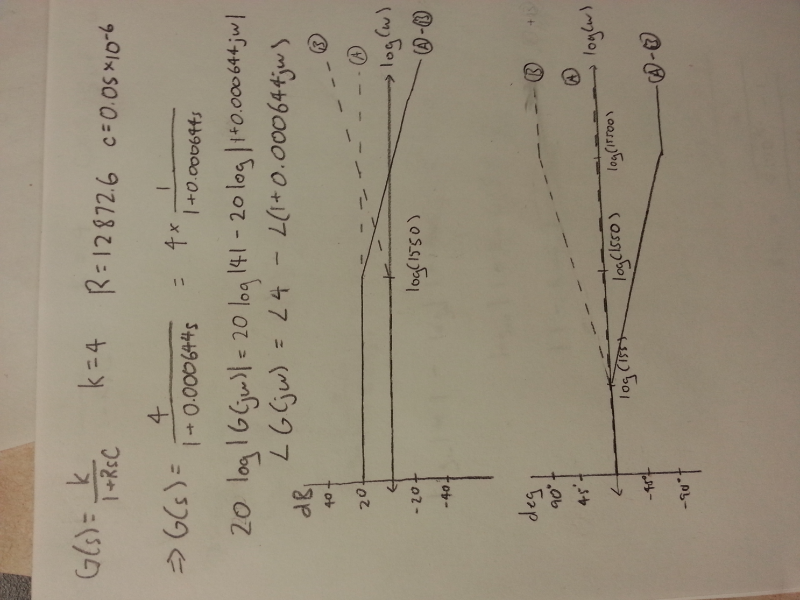

Figure 2 shows the experimental setup once we close the feedback loop, as well as the equivalent block diagram. Signs in the summing node of Figure 2 block diagram show that the two inputs into this node are added, and their sum is then negated.

Normally, the plant G(s) is put *after* the amplifier K, as you may see in future labs. However, in Figure 1 and Figure 2, the plant is positioned *before* the amplifier in order to reduce the number of operational amplifiers; buffering is required after the passive filter plant, to prevent interaction with the load.

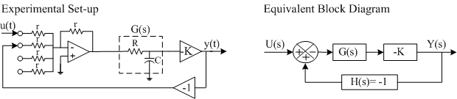

Figure 2. Closed‑loop system

f) Keeping the same R and C values as calculated above, calculate the closed‑loop bandwidth of Y(s)/U(s) when the feedback loop is closed, as shown in Figure 2.

|  |
| --- |
|  |

*Optional for this prelab*: Matlab simulations of the step response and the frequency response of the open‑loop and closed‑loop systems shown in Figure 1 and Figure 2, having the bandwidth or time constant, as applicable, marked on them. These plots are required for the Lab 2 report. A link for general Matlab commands can be found on the lab web­page ([[Matlab Tutorial](http://www.eng.uwaterloo.ca/courses/ece380/tutor1.htm)](http://www.eng.uwaterloo.ca/courses/ece380/tutor1.htm)**).**

**References**